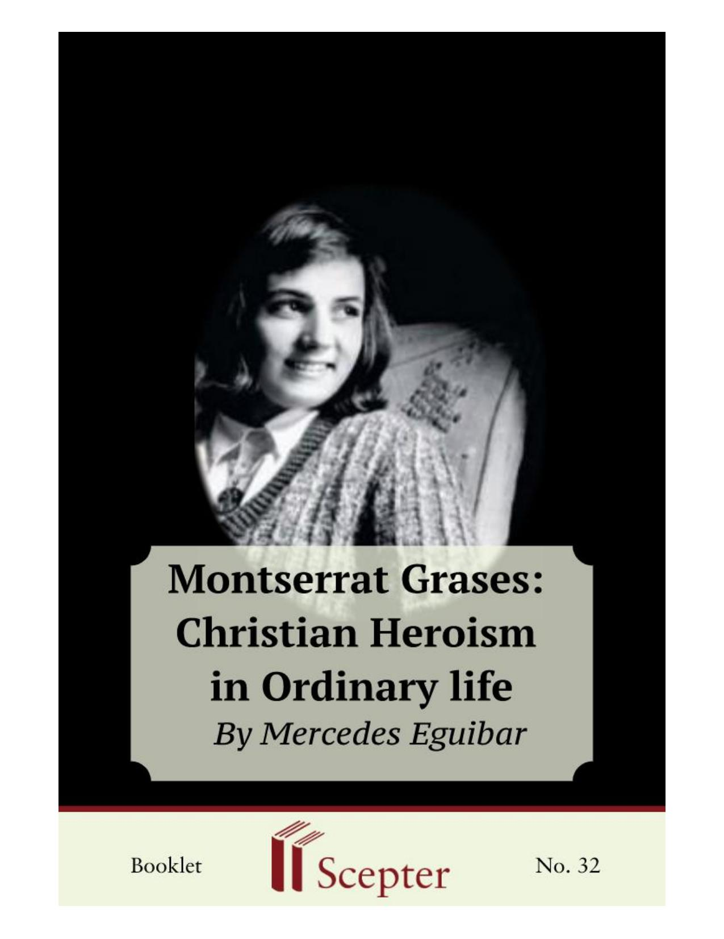
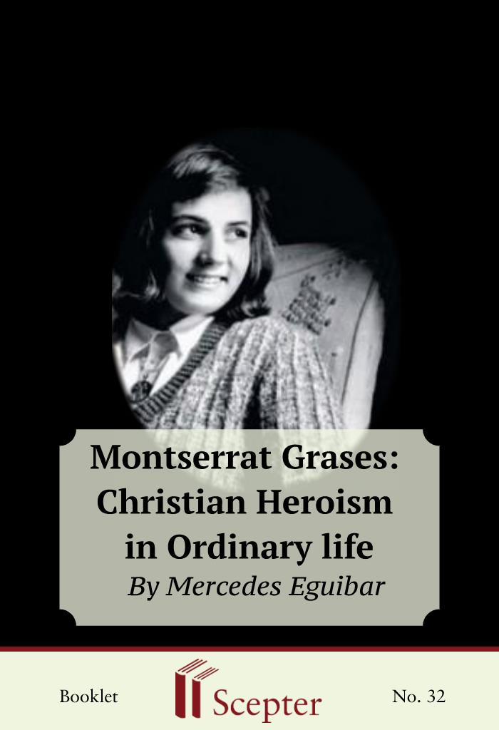


SCEPTER BOOKLETS

Montserrat Grases: Christian Heroism in Ordinary Life Nihil Obstat: Daniel V. Flynn, J.C.D. Censor librorum Imprimatur: James P. Mahoney, D.D.
Vicar General Archdiocese of New York
By Mercedes Eguibar

Scepter Publishers
PO Box 360694,
Strongsville, Ohio 44136

Toll Free: 800-322-8773 (US & Canada only) Tel: 212-354-0670
Fax: 646-417-7707

info@scepterpublishers.org

www.scepterpublishers.org

©1975 Scepter Publishers
Second Edition, © 2019
Booklet and Cover design by Parker Eidle

Booklet Number: 32

© Scepter Publishers, Inc. This information protected by copyright of Scepter Publishers, Inc., New York, NY USA. It is for the free use of readers and we encourage you to redistribute this without permission. None of this information can be sold, either in electronic or print form, unless permission has been obtained from Scepter Publishers, Inc. Direct all inquiries to
info@scepterpublishers.org.

CONTENTS

Introduction

1
Montse Comes Into Contact With Opus Dei
4
A Step Forward
6
Monte’s Serenity
8
Trip To Rome
11
Daily Examination
13
Final Days
16
Monte’s Illness Comes to an End
19
An Example of Sanctity in Ordinary Things
21
Her Memory
22

Montserrat Grases: Christian Heroism in Ordinary Life 1

INTRODUCTION

In the pages that follow you will meet Montserrat Grases, a girl who applied to her life the advice the founder of Opus Dei, St. Josemaría Escrivá de Balaguer, gives in The Way: “Do everything for Love. In that way there will be no little things: everything will be big. Perseverance in the little things for Love is heroism.”1 She died when she was seventeen. Hers was a short life, replete with contagious joy and endless enthusiasm. Her life of love and simplicity, united to suffering, can teach us that the way to happiness, to true happiness, has God as its beginning and its end.
The process for her beatification and canonization has already begun.
During the final months of her life, her cheerfulness and concern for others in the midst of great pain were an impressive sign of her sanctity, but her closeness to God during those closing days of her life cannot be separated from her heroic efforts to love Him in the ordinary life of a teen-age girl.
Montse, as her family and friends called her, was born on July 10, 1941, in Barcelona. She was the second child of Manuel and Manolita Grases, whose family eventually grew to nine children. The Grases were a close family. In their home there was a great spirit of confidence between parents and children. The children shared the cares of the family, appreciating the efforts of their parents to raise such a large family. The older ones knew how to act with responsibility, helping in every way that they could.
This family atmosphere contributed to Montse’s filial piety. She learned how to approach God in a friendly way. There was rooted in her that holy pride of feeling that she was a daughter of God. This sense of divine filiation was to be of prime importance in her spiritual life when she joined Opus Dei.
In 1952 Montse’s parents came into contact with Opus Dei, an association of Catholic lay people whose spirit was to influence their lives so much that through them it would fill their home. The spirituality of Opus Dei showed them that the Lord’s call to sanctity, “Be perfect as your heavenly 1 St. Josemaría Escrivá, The Way, Chicago, 1954, n. 813.

HELPING YOU FIND GOD WHEREVER YOU ARE
Montserrat Grases: Christian Heroism in Ordinary Life 2

Father is perfect” (Mt 5:18), is directed to all men. Those who receive from God the vocation to matrimony are called to sanctify themselves specifically through their family and professional lives. This spirit made them mindful that supernatural life has to build on a solid human base. It also reminded them of the duty they had to prepare their children to use their freedom well so that dialogue would be easy, and living together pleasant. Montse’s parents taught their children the value of work and study as means of sanctification, providing for them sound criteria for living a solid Christian life, responsibly oriented toward others.
In her home, which was “bright and cheerful” as St. Josemaría says Christian homes should be, Montse progressively assimilated the spirit that would buoy her up during her whole life, giving her a constant supernatural outlook. She would often consider that other point of The Way: “Children.
How they seek to behave worthily in the presence of their fathers! And the children of Kings, in the presence of their father, the King; how they seek to uphold the royal dignity! And you . . . Don’t your realize that you are always in the presence of the Great King, God, your Father?”2
Montse was of normal intelligence, but there was never any need to motivate her. She was a good athlete, playing basketball, tennis, and ping-pong. But her favorite recreation was outings with her friends. She had climbed most of the Montseny mountains near Seva, the village where she spent the summers.
She was also adept in manual and artistic tasks. She applied these talents diligently and with good taste to household duties, and to songs with which she helped enliven get-togethers. Her sporting spirit tempered her ascetic struggle.
Montse was a pretty girl, striking when serious. She was tall and strong, with the posture of an athlete. She had an exuberantly cheerful character with an almost continuous smile. She was dynamic, very open, sincere, and simple.
Her clothes reflected style and taste. “She especially liked a green plaid skirt, and whenever I think about Montse I imagine her in it. It was like her, simple and cheerful,” one of her friends said.

2 Ibid., n. 265.

HELPING YOU FIND GOD WHEREVER YOU ARE
Montserrat Grases: Christian Heroism in Ordinary Life 3

She always liked to be neat. When she was confined to bed, if someone said to her, “Montse, how pale you are today,” she would answer, “I didn’t get made-up. Why don’t you bring me the things? I’ll do it in a minute.” Other times, when someone would say, “You are pretty,” she would answer, “I got made-up to be beautiful when you came.”
By temperament she was lively and spontaneous. She always said things with sincerity and naturalness. After she joined Opus Dei it was called to her attention that, without losing simplicity or sincerity, she needed to be more tactful and considerate. After that she tried to avoid expressions that might offend others. Because of her strong outgoing temperament, she had a quick temper that caused her to get angry easily and to argue with her brothers. But little by little, through daily struggle, she developed a tranquil and serene character.

HELPING YOU FIND GOD WHEREVER YOU ARE
Montserrat Grases: Christian Heroism in Ordinary Life 4

MONTSE COMES INTO CONTACT WITH
OPUS DEI

When she was thirteen, Montse went for the first time to Llar, a center directed by the women’s branch of Opus Dei in Barcelona. It was Saturday, and a group of girls attended a meditation directed by a priest in the oratory of the center. After the priest read a passage from the Bible, he talked about brotherhood and apostolic interest in others. He helped those who listened to him in silence to pray, to make resolutions. Afterwards there was Benediction and singing of the “Salve Regina”. When they finished, the girls had a lively get-together in the living room.
A new phase began in Montse’s life. She went home happy and, as always, told her mother what she had done. She wanted to go back to Llar.
Her friendship with the other girls who went to the center was going to have deep roots, even though at first she was above all attracted by an atmosphere that reminded her of her own home. She was comfortable at Llar and helped in some chores when her studies allowed her free time. Thus she was slowly attracted by the atmosphere of the house and by the sincere friendship she found there. She learned how to grow in interior life with a few minutes of prayer, of conversation with our Lord every day. Close to the tabernacle, she told our Lord all her joys, her work, her struggle—a struggle especially to have a greater gentleness of character, lasting to the end of life. She sang and played the guitar at get-togethers and helped organize excursions.
This interior development in Montse was also shown in her home. The family noticed that she was more cheerful and more aware of them. The spirit of Opus Dei began to be reflected in her way of acting. She attended talks on cultural, human, and spiritual formation at Llar. In several talks they spoke of apostolic zeal, of helping others, and of giving oneself. She grasped that spirit quickly and began to feel a deep concern for apostolate which accompanied her until the last moment of her life. During those two years of formation, Montse already belonged to Opus Dei in desire. On one occasion HELPING YOU FIND GOD WHEREVER YOU ARE
Montserrat Grases: Christian Heroism in Ordinary Life 5

her mother commented: “Although Montse only asked to join Opus Dei when she was sixteen, she belonged by desire since she was thirteen.”
Near the town of St. Peter of Premia there is a conference center, Castelldaura, directed by Opus Dei. People who want religious, cultural, and human formation attend study seminars or retreats there. Montse was invited to a retreat when she was fifteen years old. For two years the weekly talks and meditations she attended, and her friendship with other girls in some way related to Opus Dei, had helped her to grow in interior life. But in this retreat, in the silence of prayer, in direct conversation with God, she discovered new aspects of the spirit of The Work (as Opus Dei is called). In a simple and natural way, almost without realizing it, she began to desire to be more generous and to put more love into her life. The possibility of total dedication to God occurred to her. When the retreat was finished she was happy but uncertain; she wasn’t sure what to do. She told her mother everything and left it in God’s hands.
Mrs. Grases encouraged her to consider her dedication to God in her prayer, to have faith so that she could give whatever God might ask of her.
Life went on as always for Montse, ready to do what God asked of her. During that time of waiting, she was inwardly strengthened. One day, certain of what God wanted of her, she told her mother that God had asked her to give her all.
A few days before Christmas Montse told her father. Then the three of them, trusting in prayer, asked God for whatever would be best for Montse.

HELPING YOU FIND GOD WHEREVER YOU ARE
Montserrat Grases: Christian Heroism in Ordinary Life 6

A STEP FORWARD

On December 24, 1957, Montse went to Llar and asked to become a member of Opus Dei.* She was radiant. She had won the struggle with herself.
She saw clearly in her prayer what Our Lord wanted of her, and she didn’t want to delay the answer.
Externally, nothing changed in her life. She continued to attend classes in home economics, cooking, and arts and crafts at Barcelona’s women’s school. She was the same. The same struggle, the same atmosphere, the same imperfections: only her heart had changed.
Montse wanted to follow well the way she had chosen. During the first few months she struggled to overcome difficulties, small faults, discouragement. She didn’t find this effort easy, but she came to love it through her generous docility to whatever our Lord asked of her.
She strove to acquire the spirit of Opus Dei quickly by living an intense life of piety, which was reflected in her confident conversation with our Lord and the Virgin Mary.
Her brother George also noticed a change. He explained his surprise at noticing how Montse stopped arguing with her brothers and sisters. She was more tactful in her dealings with them.
Montse grew closer to our Lord; she told him her desires in her prayers, and she asked to be faithful. She didn’t forget her friends; she wanted them to get closer to him every day. “Don’t you long to shout to those youths who are bustling around you: Fools! Leave those worldly things that shackle the heart and very often degrade it. . . . Leave all that and come with us in search of Love!”3 She lived this apostolic impatience as an expression of her love of God, with small sacrifices and seeking the help of her guardian angel whom she had a great devotion to.

3 Ibid., n. 790.

HELPING YOU FIND GOD WHEREVER YOU ARE
Montserrat Grases: Christian Heroism in Ordinary Life 7

She “infected” everyone near her, at times taking advantage of ingenious tricks to remember to pray for one of her friends. “Around Christmas time we decorated one of the rooms at Llar with many different colored stars. Montse gave each star the name of one of her friends. Then whenever she entered that room and saw the stars she remembered to pray for those girls,” one of her friends related.
In January 1958, she went to ski with a group of friends at “The Mill,”
one of the most important winter sports centers of the Catalonian Pyrenees.
While skiing she had a fall which left her leg sore. Thinking that she had a slight sprain, she went to the doctor. He said it wasn’t significant and recommended she use a knee pad.
The pain in her leg increased, and more rest was prescribed. She began to get up a little later in the morning. She was accustomed to helping her mother with the housework, and it was hard for her not to be able to do so.
She considered this rest as a special mortification. “When I come home from Mass Mama has done everything, and this can’t be.”
In spite of this treatment the leg did not improve. The doctor said it would help to put a cast on it. But this didn’t prevent her from going to Llar.
When her friends would kid about her bulky leg, she would laugh heartily although it ached quite a bit.
While she prayed in the oratory, she had to lean her leg on a stool. She realized that it was noticeable and didn’t like it. Once, when all the chairs were taken, a tired looking girl arrived. Little by little Montse inched her leg off the stool; then with a smile she told the other girl to sit down.

HELPING YOU FIND GOD WHEREVER YOU ARE
Montserrat Grases: Christian Heroism in Ordinary Life 8

MONTE’S SERENITY

Without knowing what she had, Montse suspected something serious was happening. She was troubled seeing the others so concerned. “I don’t want you to worry about me. Look how strong I am,” she said. And it was true.
She seemed to be full of life. Then the X-ray therapy sessions started.
Montse went without knowing what she had. “Can’t I know what’s happening? What disease do I have?” Her mother said it was something serious. She thought it best not to tell her then. She calmed her by promising to tell her later on.
As in other years, the Grases family prepared for their summer in Seva, a village in the province of Barcelona. It was July 20, 1958, a Sunday. They’d left the smaller children in the village and Montse returned to Barcelona with her parents. That morning again she had asked her father what she had. He promised to tell her when they returned to the city. They arrived quite late, and he decided to leave the conversation with her until the following day. But Montse remembered his promise. She walked into her parents’ room at one o’clock in the morning and said to them with great calmness: “Well, now that you’ve settled down, let’s see if you can tell me everything.” It was her father who told her that she was suffering from cancer of the bone. “She reacted with such naturalness that we were amazed,” he recalled.
“And if they cut off my leg?” was her only question. They told her that the only solution was to leave everything in God’s hands.
Montse understood. She wasn’t frightened. She went back to her room.
Her mother thought she should sleep in Montse’s room that night, convinced that she had made a great effort to dominate herself, but that afterwards Montse would have a hard time. When Mrs. Grases walked into Montse’s room, she saw her sitting on her bed, making her examination of conscience as she did every night. Within five minutes she was sleeping peacefully.
The serenity of Montse’s reaction isn’t easily explainable. It’s necessary to look to her deep-rooted interior life, acquired in union with God. Montse HELPING YOU FIND GOD WHEREVER YOU ARE
Montserrat Grases: Christian Heroism in Ordinary Life 9

had organized her life as a loving dialogue with our Lord. In this dialogue she offered him her life. Now God himself came to take it. Montse while still a child had learned the most difficult lesson: how to embrace lovingly the most holy will of God.
On the following morning, Montse went to Llar. After greeting our Lord in the oratory, she knocked at the directress’s office. “I’d like to speak with you whenever you can,” she told her calmly. While she waited, she did some ironing. In a little while Montse was heard singing in Mexican style: “When I lived most happily without thinking of affection, you wanted me to love you; and I loved you with a passion. And I will continue to love you until after death. I love you with all my soul, and the soul never dies.”
The directress relates: “I went first to the oratory and then called Montse. I had feared this moment, and now that it had arrived I tried to appear calm; but I didn’t succeed because Montse said to me: ‘Were you crying Lia?’ Then she immediately said: ‘You’re clever. So you knew everything and you didn’t tell me a thing. But now I know because yesterday papa told me.’”
“And now what Montse?” the directress asked. “I’m ready. I just came from confession, and I’m very happy,” she answered. The conversation continued in such a supernatural tone, with such a wholehearted acceptance of God’s will, that it was overwhelming. “Montse’s face reflected an enormous peace while she told me of the conversation with her parents the previous night. ‘Surely mama expected me to say something, but nothing occurred to me. I just thought that I had to be strong. I kissed my crucifix and said serviam
[I will serve].’ She told me that she realized how much her parents suffered when talking with her about her illness.”
From then on, she spoke of her death with great naturalness, even though she found it hard to believe because the pain in her leg diminished.
She immediately wrote to the Founder of Opus Dei, telling him everything and asking him to pray that she would know how to be strong and offer her sufferings for the Work. “I’m not afraid of pain because I think that if I’m faithful to God each day in what he asks of me, he will help me when the hard part comes.”
A few days later she returned to Seva with her parents. Montse’s naturalness and cheerfulness surprised everyone who knew about her serious HELPING YOU FIND GOD WHEREVER YOU ARE
Montserrat Grases: Christian Heroism in Ordinary Life 10

illness. Nothing in her had changed. A friend of hers said: “When I found out about Montse’s illness I was confused, and it was difficult for me to be natural with her; I didn’t know how to act. Montse removed my fears because she acted the same as usual, as though nothing had happened. She was still happy, lively, and friendly.” The only noticeable thing was a bit of a limp, and when she was asked about it she said, “Oh, some people are always putting on an act.”
Montse continued going on outings with her friends. She danced Sardanas, a folk dance from that region in Spain, and even took part in a benefit presentation of a play called “The House of Quiros.” She had the role of an old lady and was quite charming in it.
When her mother saw her carry on this way she was afraid she had forgotten that she was going to die soon, and one day she asked her:
“Montsita, do you think you’re going to be cured?” She answered, “No.”
Montse never had a sick person’s mentality, and at first she was bothered when people treated her that way. She tried to act with the greatest normality in her daily life as far as she could. Some days people could notice her suffering, but she always made light of it; she never spoke of her illness, and she had a special knack for changing the topic of conversation.

HELPING YOU FIND GOD WHEREVER YOU ARE
Montserrat Grases: Christian Heroism in Ordinary Life 11

TRIP TO ROME

On September 24th a new phase of her disease began, with a lot of pain.
From then on it grew rapidly worse. In spite of this, Montse was able to carry out one of her greatest desires, to go to Rome. “Catholic, Apostolic, Roman! I want you to be very Roman, ever anxious to make your ‘pilgrimage’ to Rome, videre Petrum —‘to see Peter.’”4
On many occasions Montse had expressed a desire to go to Rome to meet the pope and Monsignor Escrivá, the founder of Opus Dei. Her parents wanted to satisfy this wish.
Montse’s joy was very great. “What else should I take?” she asked me.
“Should I take my high heels? I can hardly put them on any more. But in Rome I’ll put them on.”
She left Barcelona by plane on November 11th. Her parents saw her off at the airport.
In a letter she wrote to her father on the 13th she said: “I’ll tell you about the trip in great detail later. From Milan to Rome the weather was devilish.
The plane bounced like crazy. No need to tell you I was scared and dizzy. But when I arrived, everything was fine. Pepa was at the airport. I was very excited and they took good care of me.”
While in Rome Montse lived in “Villa delle Palme,” a residence directed by the women’s branch of Opus Dei.
The day after arriving she met Monsignor Escrivá. She told her mother in a letter: “We went to the room where the Father received me. He asked about my parents and my brothers and sisters and I told him you were all well. We went to a gallery and took two pictures to send to you. Papa, you’ve probably received them. What a thoughtful detail, don’t you think?”

4 Ibid., n. 520.

HELPING YOU FIND GOD WHEREVER YOU ARE
Montserrat Grases: Christian Heroism in Ordinary Life 12

She spent four days in Rome. Her visit to St. Peter’s, the center of the Catholic world, left her deeply impressed. Besides, she must have experienced those words written in The Way: “Catholic! A great heart, an open mind.”5
She felt the warmth of a family in “Villa delle Palme” when she saw girls of different countries and ages gathered there in unity of spirit. “You can’t imagine,” she wrote to her mother, “there were so many of us from so many different places. There was one girl from Venezuela, one from Guatemala, a real young girl from Peru. . . .” All this and a thousand other details were engraved in her soul in such a way that later they helped her accept with great serenity the sufferings that our Lord wanted to send her.
Returning from her trip to Rome, she sent a postcard to the Central Directress of the Women’s Section of Opus Dei. It said: “Terrific trip.
Everything’s fi ne. I’m about to arrive and ready for ‘everything.’ It’s worthwhile. Montse.”
One of the most admirable traits in Montse was her concern for others, even in the midst of a lot of pain. Her brother had a hobby of collecting bottle caps. He gave Montse the job of bringing him some from Rome. She knew his enthusiasm and remembered his request. In a letter to her father from Rome she said: “Tell Nacho that the bottle cap business is in good hands and I’ll bring him a lot for sure.”
As Montse walked along the streets of Rome, she remembered Nacho.
Whenever she passed a sidewalk cafe she looked at the ground. Again and again she stooped to pick up those important bottle caps. In a letter to the friends she left in Rome she wrote on November 19th: “When I arrived home, in spite of everything, Mother didn’t want me to start opening packages. It was impossible. Everything came out—gum, candy, balloons, bottle caps.
Ignatius was crazy with joy. He just kept counting and recounting them.”
After this trip, Montse became worse. On the days before the feast of the Immaculate Conception, she went to Llar almost every day, making a great effort. In reality they took her, because she couldn’t take a step. “I took her in a cab some days,” a friend said, “because otherwise she couldn’t have gone.” It was difficult for her to get into the car, and she would joke: “I need taxis made to order.”

5 Ibid., n. 525.

HELPING YOU FIND GOD WHEREVER YOU ARE
Montserrat Grases: Christian Heroism in Ordinary Life 13

DAILY EXAMINATION

“We were reading—you and I—the heroically ordinary life of that man of God. And we saw him struggle whole months and years (what an
‘accounting’ he kept in his particular examination of conscience!): one day at breakfast he would win, the next day he’d lose . . . ‘I didn’t take butter . . . I did take butter!’ he would jot down. May we too—you and I—live our . . .
‘drama’ of the butter.”6
Montse also lived her “drama of the butter.” Day by day, with freedom of spirit and fidelity she jotted down her faults, her struggle to win God’s love.
In the notebook she used for her examination of conscience, a valuable written memory, we see how this young girl came closer and closer to intimacy with God on the basis of demanding little things of herself. She realized that a remedy to overcome weakness, forgetfulness, and reluctance, and a way to vitalize love of God, is a daily review, united to a fi rm resolution.
Every night until the end of her life, Montse would recollect for a few minutes in the presence of God: “What did I do today that was pleasing to God? What did I do that was displeasing to him?” And right away after this: “What could I have done better?” The resolution came as a consequence. She knew quite well that the only way to not grow cold in love is to keep throwing wood on the fi re—acts of faith, hope, and charity, spiritual communions, acts of reparation, aspirations, acts of love in serving others. “Give him what you can: the merit is not whether it is big or small, but in the intention with which you give it.”7 This is the way she built her fi re: sometimes just sparks; at other times, a huge flame that gives light and warmth.
She never failed to make her daily examination of conscience. Two days before her death she said, “The last three days, I’ve been taking a long time to make my examination,” (because she was so ill).
She had concrete points as guidelines for her talks with God: on Monday, lukewarmness; on Tuesday, the Rosary; on Wednesday, the Gospel; 6 Ibid., n. 205
7 Ibid., n. 829.

HELPING YOU FIND GOD WHEREVER YOU ARE
Montserrat Grases: Christian Heroism in Ordinary Life 14

on Thursday, humility; on Friday, divine filiation; on Saturday, mortification; on Sunday, faith, hope, charity, love, and confidence.
A person can notice, step by step, the constant progress of her interior life and the demands she made on herself. In her notes, she started with: “It’s hard for me to pray, disorder in my mortifications.” At the hour of rising:
“Conquer yourself each day from the very first moment, getting up on the dot, at a set time, without granting a single minute to laziness”;8 at dinner: “The day you leave the table without having made some small mortification, you will have eaten like a pagan.”9 “Why should you look around you, if you carry
‘your world’ within you?”10
Punctuality at meals and going to class. . . . Not using the elevator at her house, but rather walking up the stairs. . . . In this constant struggle she didn’t let lukewarmness separate her from her friendship with God.
“Fight against the softness that makes you lazy and careless in your spiritual life. Remember that it might well be the beginning of tepidity . . .
and, in the words of Scripture, God will vomit out the lukewarm.”11
“I’ve sighed a lot saying: ‘Lord!’” wrote Montse, “but I rectified immediately: You will help me! Today I’ve fought a lot to be happy and content.” Next to it a resolution underlines: “Little will and as a result remorse, anger, and impatience. Cheerfulness in spite of all this! Yes.”
As she grew in life, her example was even more delicate: “Mortifications are hard, but better.” Later: “Today, so so. Some laziness, little peace, later on I overcome it with joy.” Another day: “A lot of joy and a bit of bad temper,” or
“I’m still missing a lot of what is called spirit of mortification.”
“I seek myself,” also appears in her notes. Some days: “I pray easily, perhaps I’m seeking myself.” Then: “Lately, it’s going better.”
During the last phase of her life, Montse lived so close to God that externally you couldn’t notice that she was in pain; she only thought of the others. One night she wrote: “I want to rest, I lack generosity.” Later on, her desire to give herself was such that she said: “I made my prayer on the basis 8 Ibid., n. 191
9 Ibid., n. 681.
10 Ibid., n. 184.
11 Ibid., n. 325.

HELPING YOU FIND GOD WHEREVER YOU ARE
Montserrat Grases: Christian Heroism in Ordinary Life 15

of desiring it.” And she copied from somewhere: “Mother of mine, because of all my miseries, tell our Lord that I can’t take any more. Mother of mine, because of all my infidelities, tell our Lord that I can’t take any more. Mother of mine, because of all the foolish things I do each day, tell our Lord that I can’t take any more. But Mother of mine, you know that it’s yes, that I can take more.”
At the end of her life, her struggle was harder. But Montse was strong.
Together with her cheerfulness and acceptance of death, she still accused herself: “I’ve complained enough; but I fought. Some disheartening moments; but in spite of everything joy.”
The last trial which our Lord sent her, can be seen in a few words that she wrote just a few days before she died: “Lack of peace, anxiety, alone.”
During those moments she repeated constantly: “Sweet Heart of Mary, give us peace.” “Cause of our joy, pray for us.”
For those who read about her life, it flows like a peaceful stream. It is within our reach. It can be imitated. It is even attractive. Without trying she taught us to think of this great love that our Lord had for the Blessed Virgin.
This was noticeable when she would insist at the beginning of a time of meditation: “Read me something from The Way about Love.”

HELPING YOU FIND GOD WHEREVER YOU ARE
Montserrat Grases: Christian Heroism in Ordinary Life 16

FINAL DAYS

Little by little, her illness followed its course. Now she spent sleepless nights; the treatment made her suffer a lot. Her pain increased to the point of being almost unbearable. From February 16th on, her leg was so swollen up to the hip that her skin began to crack. Treating the leg was terribly painful.
But instead of complaining, she hummed a song. She always had an affectionate word for those who treated her leg, even though they couldn’t help hurting her.
This pain that she accepted with such fortitude was always offered for the Pope and for the Founder of Opus Dei. She felt very sorry for the sick and asked about them. She was an example to all those who visited her. Being with her, people breathed serenity and peace. It was moving to see her overflowing with youthfulness and joy. She knew how to cover up that tremendous suffering with such charm, turning the conversation to topics that interested others. Many were impressed by her humility, her great simplicity and the slight importance she gave to her own doings and her own illness. “Anyone else in my place and at my age who belonged to Opus Dei would do the same thing,” Montse said. She couldn’t eat. To take anything was a real torture.
Since she couldn’t swallow anything, she sucked on a piece of ice for refreshment.
She usually commented that she was a coward because she was afraid the suffering would come. “But what you’re doing now. What is that if not suffering?” someone asked her one time. “This is nothing!” She was to die in a few days.
Another day she called her father and said to him: “Papa, are you happy?” She asked the same thing of the others, adding: “We’re the happiest family in Barcelona. When I die, I don’t want anyone to be sad; there has to be joy.”
From the first moment, Montse faced the idea of death with serenity.
Nevertheless, we cannot forget that she continued to be a young girl of extraordinary vitality who had just celebrated her 17th birthday. On occasion HELPING YOU FIND GOD WHEREVER YOU ARE
Montserrat Grases: Christian Heroism in Ordinary Life 17

she showed a certain sadness at leaving all that. But then she would immediately think how worthwhile her sacrifice was. She felt afraid to die.
One day she said to a friend: “I’m afraid of dying, because I’m afraid to be alone.” Her friend tried to encourage her by mentioning the scene of Jesus in Gethsemane. “What joy to find myself with Jesus, the man who, in the garden, was afraid as I am,” Montse commented. Together with this joy in the face of death she put her hope in Heaven. “Do everything unselfishly, for pure Love, as if there were neither reward nor punishment. But in your heart foster the glorious hope of Heaven.”12
When she could hardly speak she would often say, “Tell me things about Heaven.” She didn’t doubt for a moment that the Lord would take her to Heaven, and she spoke about it with great naturalness. She accepted recommendations to make there. To console the others, she frequently said:
“I assure you that from Heaven, I’ll help you a lot. I’ll never leave you.” “We always left that room refreshed, without knowing why,” a friend of hers said.
Overcoming herself was exhausting. “You see how weak I am. I don’t know why you say I’m strong.” Then they would tell her about other visitors; and Montse, realizing that she wasn’t there to do her own will, would say,
“Fine, let them come in.”
The end drew to a close rapidly. At the beginning of March they had to call the doctor quickly because Montse had such a weak pulse that it was hardly noticeable. The doctor, when he took her pulse couldn’t hide an expression of concern that was noticed by all. Montse broke the anguished silence by picking up the doctor’s bag from the bed and saying: “Mama, have you seen this strange bag?” This made everyone smile.
She grew much worse. They thought the moment had arrived to give her the Blessing of the Sick. She also thought it would be good to have it as soon as possible. A priest of Opus Dei administered this sacrament. Montse followed the ritual with great devotion, showing no sadness. Every once in a while she smiled at her mother who knelt at the foot of the bed.
On the eve of the feast of St. Joseph, it seemed that the hour of her death had arrived. Montse was very happy. “How do I look,” she asked those who were staying with her. “All right,” someone answered. Montse wanted them 12 Ibid., n. 668

HELPING YOU FIND GOD WHEREVER YOU ARE
Montserrat Grases: Christian Heroism in Ordinary Life 18

to say, “Worse.” And when asked, “How do you feel?” she answered unenthusiastically, “Me? Fine; just look.” The clock struck eleven, and she asked, “What time is it? Am I still here?” At twelve she was asked, “Montse, do you want to pray?” They said the Angelus. At that moment she was more awake, and she said: “Do you know what I think? I’m not going to worry any more. When God wants, he’ll take me.”
St. Joseph’s day passed, and her general condition improved somewhat.
The doctor came to see her, and Montse asked later: “What did he say? What’s happening? Aren’t I going?” “He said you might go at any moment,” they answered. “Can you imagine? Soon to Heaven, soon to Heaven. Will you let me go?” she exclaimed happily, hugging the person who had told her the doctor’s comment.
Little by little she weakened. The nights were the worst. A continuous sweat left her exhausted. She became very thirsty and felt suffocated.

HELPING YOU FIND GOD WHEREVER YOU ARE
Montserrat Grases: Christian Heroism in Ordinary Life 19

MONTE’S ILLNESS COMES TO AN END

The night before her death, Montse wanted to say something. But in spite of the effort she made no one could understand her. Early in the morning of that Holy Thursday, March 26, 1959, the directress of the Opus Dei house that she attended was close to her bed, and Montse asked her to say aspirations since she herself couldn’t talk anymore. About ten o’clock she tried to sit up to see the picture of our Lady that she had in front of her bed.
She whispered: “How much I love you. When are you coming to take me?”
These were her last words. Her life ebbed away little by little.
At noon, those who were with her prayed the Angelus. She must have followed it with her heart. It was her last glance toward the One she loved so much, and to whom she had said so many things during her lifetime. Those who were with her began to say the Rosary in a soft voice, and they had just finished the first mystery when Montse died.
It was 1:20 p.m. on Holy Thursday when she went to Heaven. She died as she had wanted to: “In a bed, but squeezed like a lemon until there is not a drop left.” She frequently repeated these words with which the founder of Opus Dei referred to the efficacy of a life dedicated to God.
At the moment of her death, her parents and some friends, who like Montse belonged to Opus Dei, were in her room; her brother Enrique arrived a few moments later.
When the news of her death spread, many people impressed by the testimony of her life wanted to visit and pray before her. Her parents, despite their deep sorrow, maintained a serenity that could only be explained by the deep Christian meaning of their lives. “In a case like this,” commented the pastor of the Church of Our Lady of the Pillar, “instead of being sad and offering sympathy, you have to intone the Alleluia.”
People spoke of how quickly Montse had acquired the spirit of Opus Dei, of how the grace of God had worked so amazingly and so swiftly in Montse’s soul.

HELPING YOU FIND GOD WHEREVER YOU ARE
Montserrat Grases: Christian Heroism in Ordinary Life 20

Montse knew what it was to have a profound interior life in the midst of one’s daily occupations. She sanctified herself as an ordinary Christian, helped by the means she found in Opus Dei—the same spiritual means that help thousands of other souls all over the world live a Christian life dedicated to our Lord—with naturalness, being salt and light and demonstrating with the testimony of their lives that it is possible to follow and imitate Jesus Christ closely in the most diverse circumstances of one’s daily activities.
Montse’s death, the same as her life, occurred without spectacle or noise. It was the crowning of a generous life that became more heroic and dedicated during a long trial of great suffering.

HELPING YOU FIND GOD WHEREVER YOU ARE
Montserrat Grases: Christian Heroism in Ordinary Life 21

AN EXAMPLE OF SANCTITY IN ORDINARY
THINGS

Even during Montse’s life many people confided in the efficacy of her prayer. Since her death, this confidence has spread to people who lived with her, friends, school companions, and others who didn’t know her personally.
Today, the number of persons who are certain they have received favors through Montse’s intercession and who privately invoke her name is truly great. She never gave the impression of doing anything extraordinary, as though she wished to tell us that sanctity isn’t something removed from ordinary life but that it is the serene, cheerful, simple, and at the same time, heroic correspondence to the will of God.
Although Montse wanted to pass unnoticed, the Lord set her as a light on a candlestick to move many souls to seek sanctity in the middle of their ordinary life. Those who knew her, especially during the last months of her life, were convinced that they had received a lesson in sanctity.

HELPING YOU FIND GOD WHEREVER YOU ARE
Montserrat Grases: Christian Heroism in Ordinary Life 22

HER MEMORY

Her memory has remained with us. While her process of beatification continues, the life of Montse will be studied and analyzed in detail. The Church does things well, but slow and methodical. It is going to ask: Why her serene smile? Why her small sacrifices? What about sports, work, singing, sickness, and study? How did she know how to combine these natural realities with other supernatural realities? And how did she make use of God’s grace?
What of her relationship and friendship with God?
Her memory lives on. Having belonged to Opus Dei, which Pope Paul VI has described as “a living realization of the eternal youth of the Church,”
she is an inspiration for those who, in the world and from the world, in any state of life, try to give their life a higher meaning, so that through it, the
“everyday things,” their work, the fulfillment of family or social duties, will be a holocaust to God and an instrument to make others happy.
Perhaps we will have to wait many years until the Church gives the last word about Montse’s life. But the truths she lived received solemn formulation in the documents of the Vatican Council: “The laity . . . , are called upon, as living members, to expend all their energy for the growth of the Church and its continuous sanctification, since this very energy is a gift of the Creator and a blessing of the Redeemer.”13 “The laity, dedicated to Christ and anointed by the Holy Spirit, are marvelously called and wonderfully prepared so that ever more abundant fruits of the Spirit may be produced in them. For all their works, prayers, and apostolic endeavors, their ordinary married and family life, their daily occupations, their physical and mental relaxation, if carried out in the Spirit, and even the hardships of life, if patiently borne—all these become ‘spiritual sacrifices acceptable to God through Jesus Christ’ (I Pt. 2:5).”14

13 Second Vatican Council, Constitution on the Church Lumen Gentium, n. 33
14 Ibid., n. 34.

HELPING YOU FIND GOD WHEREVER YOU ARE


Montserrat Grases: Christian Heroism in Ordinary Life 23

We want to help you become a saint every day, from right where you are and share Christ with others.
Have you ever tasted the beauty of God’s presence? It's natural to want to experience his closeness more often—as often as you can! As St. Josemaría Escrivá said: “Either we learn to find our Lord in ordinary, everyday life, or else we never find Him.”
We can help you discover and grow closer to God every day in your work, family life, and other ordinary activities. We want you to become a saint and everything we publish and do is directed towards that goal.
Thank you
Thank you for reading the booklet. Please feel free to redistribute the booklet to anyone who might benefit from it. If you are interested in similar reading, see the related books below.

HELPING YOU FIND GOD WHEREVER YOU ARE

